**Java Vocabulary**

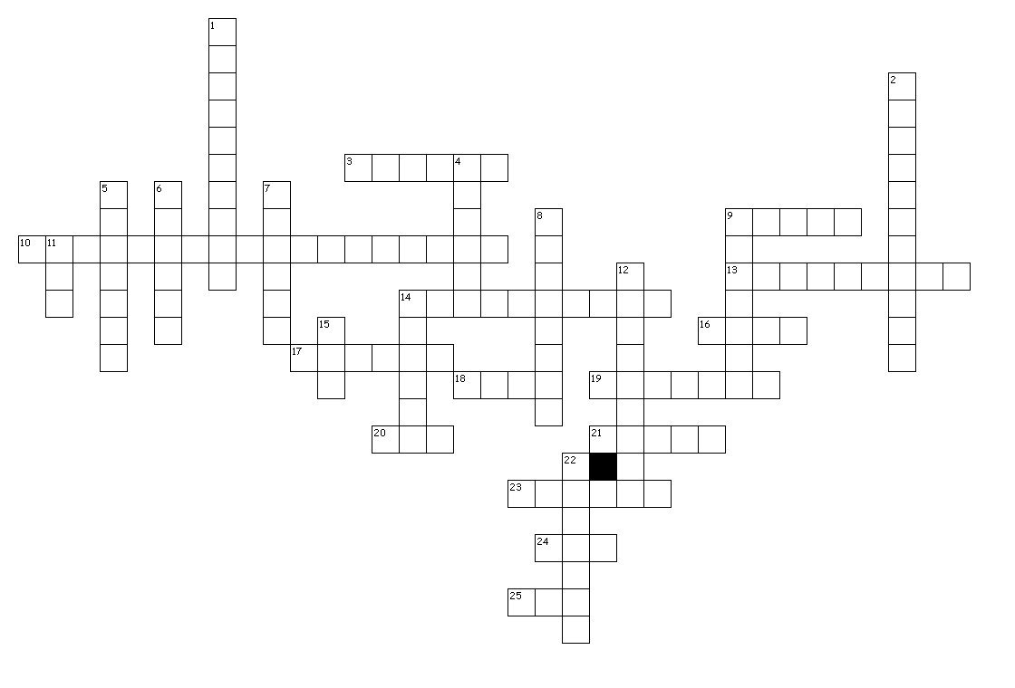

Across

3. The Java keyword that says anyone can access this component

9. Method in System.out that prints on the same line

10. What the single equals sign is called in Java

13. Naming convention that starts with lowercase then uses capital letters to separate words

14. The part of a class that describes or makes up the object

16. The method in the Runner class

17. Tool used for source control

18. Java keyword that means nothing comes back

19. Java type that is used for text input

20. Java keyword that instantiates an object

21. Java keyword that refers to the blueprint for an object

23. Java type that can store text of any language using Unicode

24. Where Java programs are executed

25. Java keyword for a counting number

Down

1. The Java class that has the start method

2. What the period is called in Java

4. Java statement used to add reference to external classes

5. Method in System.out that prints a line of text and moves to the next line

6. The Java class that starts a program

7. A block of code that is analogous to a verb

8. What Java code is compiled into

9. Folders used to organize classes in Java

11. Folder that contains all packages

12. Ends every statement in a Java program

14. Java keyword for a number with a decimal point

15. Folder that contains all .class files

22. The Java keyword that says only the current class can access this component